Atitit if else 选择决策流程ast对比 sql java

表达式类型 binaryExpression hase left and rit expr

目录

1.1. Sql 1

1.2. groovy 2

1.3. Java 2

1.4. Lisp 4

1.5. Js 4

1.6. Mybatis xml 4

## Sql

package com.alibaba.druid.sql.ast.statement;  
  
import com.alibaba.druid.sql.ast.SQLExpr;  
import com.alibaba.druid.sql.ast.SQLObjectImpl;  
import com.alibaba.druid.sql.ast.SQLStatement;  
import com.alibaba.druid.sql.ast.SQLStatementImpl;  
import com.alibaba.druid.sql.visitor.SQLASTVisitor;  
import java.util.ArrayList;  
import java.util.Iterator;  
import java.util.List;  
  
public class SQLIfStatement extends SQLStatementImpl {  
 private SQLExpr condition;  
 private List<SQLStatement> statements = new ArrayList();  
 private List<SQLIfStatement.ElseIf> elseIfList = new ArrayList();  
 private SQLIfStatement.Else elseItem;

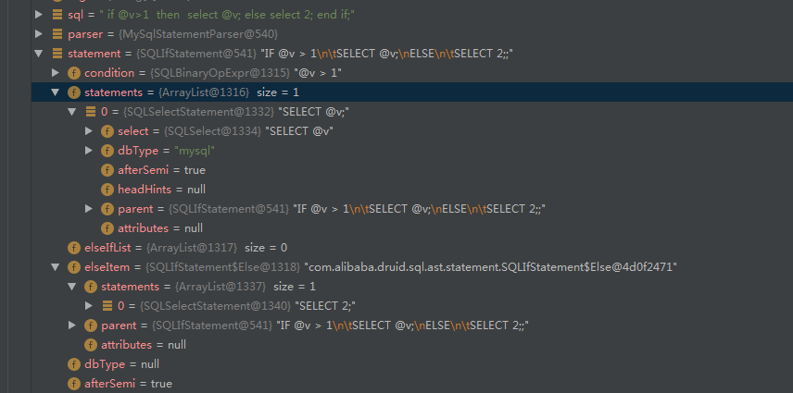

## groovy

package org.codehaus.groovy.ast.stmt;  
  
import org.codehaus.groovy.ast.GroovyCodeVisitor;  
import org.codehaus.groovy.ast.expr.BooleanExpression;  
  
public class IfStatement extends Statement {  
 private BooleanExpression booleanExpression;  
 private Statement ifBlock;  
 private Statement elseBlock;

## Java

package org.eclipse.jdt.internal.compiler.ast;  
  
import org.eclipse.jdt.internal.compiler.ASTVisitor;  
import org.eclipse.jdt.internal.compiler.codegen.BranchLabel;  
import org.eclipse.jdt.internal.compiler.codegen.CodeStream;  
import org.eclipse.jdt.internal.compiler.flow.FlowContext;  
import org.eclipse.jdt.internal.compiler.flow.FlowInfo;  
import org.eclipse.jdt.internal.compiler.impl.Constant;  
import org.eclipse.jdt.internal.compiler.lookup.BlockScope;  
import org.eclipse.jdt.internal.compiler.lookup.TypeBinding;  
  
public class IfStatement extends Statement {  
 public Expression condition;  
 public Statement thenStatement;  
 public Statement elseStatement;  
 int thenInitStateIndex = -1;  
 int elseInitStateIndex = -1;  
 int mergedInitStateIndex = -1;

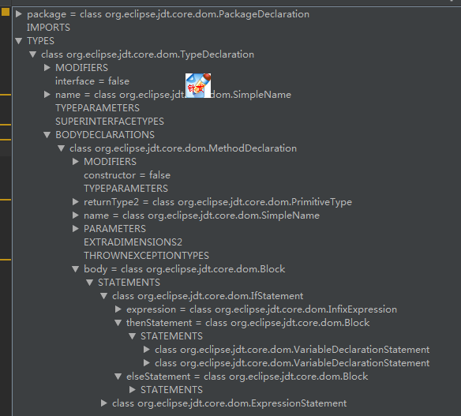

## Lisp

## Js

//  
// Source code recreated from a .class file by IntelliJ IDEA  
// (powered by Fernflower decompiler)  
//  
  
package jdk.nashorn.internal.ir;  
  
import jdk.nashorn.internal.ir.annotations.Immutable;  
import jdk.nashorn.internal.ir.visitor.NodeVisitor;  
  
@Immutable  
public final class IfNode extends Statement implements JoinPredecessor {  
 private static final long serialVersionUID = 1L;  
 private final Expression test;  
 private final Block pass;  
 private final Block fail;  
 private final LocalVariableConversion conversion;

## Mybatis xml

package org.apache.ibatis.scripting.xmltags;  
  
public class IfSqlNode implements SqlNode {  
 private final ExpressionEvaluator evaluator;  
 private final String test;  
 private final SqlNode contents;